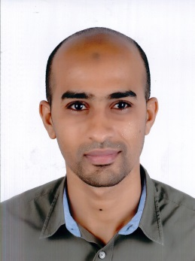

El Hamza Mourad Sayed

26 Essmat st. Maadi

, Cairo, Egypt

### Mob: 01289777111

### E-mail: [hamzawyas@hotmail.com](mailto:hamzawyas@hotmail.com)

***PERSONAL INFORMATION***

Date of Birth: 11/05/1983

Gender: Male

Marital Status: Married

Nationality: Egyptian

Military Service: Exempted

***Academic Qualifications:***

|  |  |
| --- | --- |
| **Cairo University, Cairo, Egypt**  Bachelor of Commerce 2013  Arabic Section Accounting Class (Acceptable) |  |
| ***Objective:***  Seeking a position in the customer service department where my skills and abilities, together with my enthusiasm and motivation can be utilized to make a difference to and with a reputable organization, and help achieve its goals. |  |

***EXPERIENCE*:**

**Orange Cairo, Egypt e-signature logo 2**

**10 years in Sales Contracts, Commercial.**

* Manage the retrieval of contracts
* Handle contracts data uploading process

**1 year in Sales Commission and Channel Deve;opmint, Sales Consumer.**

**1 year in Sales Reporting & Analysis, Sales Consumer.**

**3 years in Coordinator, Fleet Operations, Human Resources & Corporate Support.**

**ABM** **Company**

|  |  |
| --- | --- |
| Working for two years in medical accessories company.  **Kadeem Photo gallery**  Working Designer for three years in kadeem for print photography |  |

***Computer Skills:***

Very Good use of basic MS-Office applications (Word, Excel, PowerPoint, Outlook)

***Language Skills:***

Arabic: Native

English: Very Good.

***Personal Skills:***

* Very good communication skills
* Very good presentation skills
* A good negotiator
* Able to work well, both individually and in teams
* Enthusiastic and self-motivated
* Special experience at advertising field and little knowledge about marketing field
* Database management
* Strong customer service skills
* Effective at customer communication
* Proficient networking skills
* Efficient at keeping client records